**Exemplar: Calculating the number of working days remaining in the year**

**Overview**

In the exercise *Calculating the Number of Working Days Remaining in a Year*, you were asked to put into practice what you had learned about date functions and calculations in Microsoft Excel.

Your task in this exercise was to create formulas to generate date and timeline information in the spreadsheet.

The tasks you had to complete included the following:

* Create a formula that displays the total number of calendar days between the start date and the deadline date for each project.
* Use a function to calculate the number of working days between the start date and the deadline date for each project.
* In the calculation to determine the number of working days available, exclude both Federal Holiday dates and weekend dates.
* Extract the month and year information from the deadline date to display them as separate pieces of information in two columns.

This reading provides you with a step-by-step guide for identifying these results. It also includes screenshots that you can compare against your own work.

You can review the formula creation techniques for this exercise in the video *Dynamic date and time entries* and the reading *Other useful date calculations*.

**Step 1: Download the file**

1. You downloaded and opened the Excel workbook *Advertising Campaign USA Dates.xlsx***.** The workbook contained one worksheet called **USA Launch Dates**that included the start and deadline dates for each project. It also contained a list of all Federal Holiday dates for 2023 and 2024 and the current date in cell **B1**.

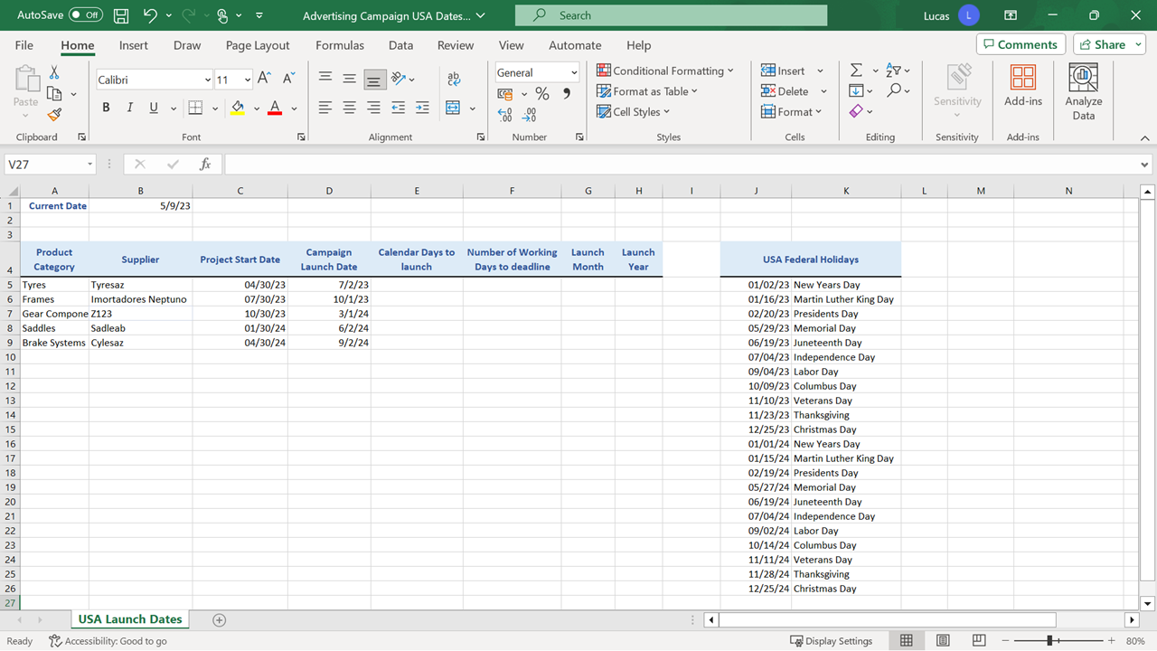

**Step 2: Creating the Calculations**

**Please note**: If your version of Excel is not set to United States regional settings and does not display dates in the MM/DD/YY format you were asked to skip tasks 1 and 2 below.

1. In cell **B1**, you created a formula using the **TODAY** function to display the current calendar date. This is a formula so it will recalculate and update the calendar date every 24 hours. The formula in **B1** was:

**=TODAY()**

The formula contained an opening and closing bracket after the **TODAY** function name but had no characters between the brackets. The result generated in **B1** was the current calendar date according to the system clock on your PC.

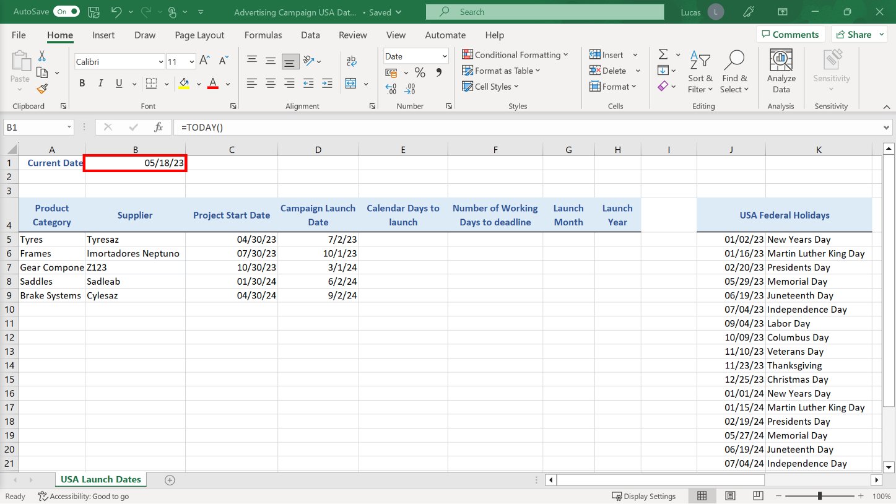

1. In a real-life situation, you would continue to use the **TODAY** function in **B1** so that the current date displayed is dynamic and will update every 24 hours. Here you were asked to change the entry to the static date 05/09/23 so that your results would match the samples given below. The date should be in MM/DD/YY format.
2. In cell **E5** you had to create a subtraction formula to calculate the number of calendar day between the date in cell **B1** and the deadline date in **D5**.

The entries in **B1** and **D5** are both serial numbers formatted to display as calendar dates. The date in **B1** is an earlier date than the one in **D5**. This means that the serial number for the date in **B1** is smaller than the serial number for the date in **D5**.

The formula in **E5** took the larger number in **D5** and subtracted the smaller number in **B1**. However, the formula had to be copied down to row **9**. So, the cell reference **B1** required dollar signs to stay constant during the copy operation.

The formula should read:

**=D5-$B$1**

The result of this formula is **54**.

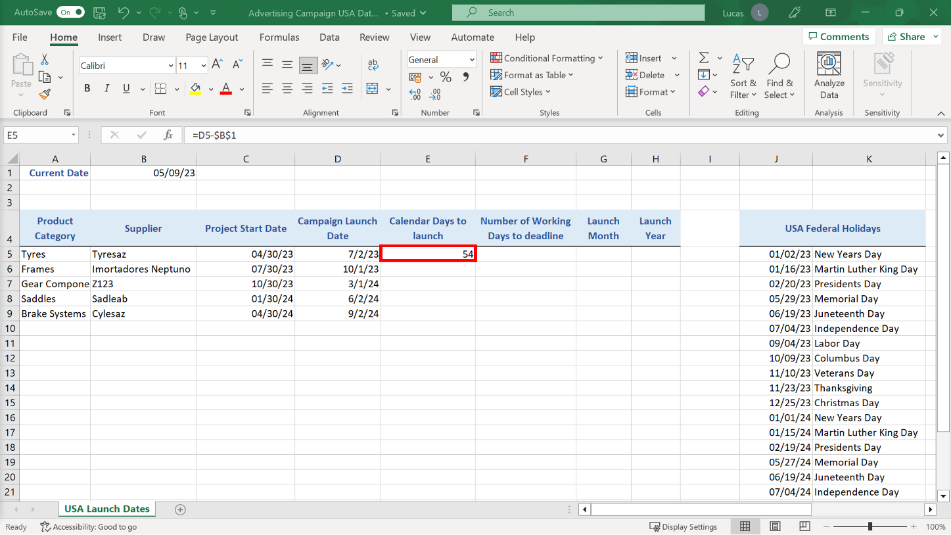

1. You had to create a formula in cell **F5** using the **NETWORKDAYS** function to calculate the number of weekdays between the date in **B1** and the deadline in **D5**. The formula had to include an additional argument so that, when Excel calculated the formula, the Federal holiday dates in the cell range **J5** to **J26** were excluded from the result of the **NETWORKDAYS** calculation. The **NETWORKDAYS** formula displayed ignored any date falling on a Saturday or Sunday, which are the two days that constitute a weekend in the USA.

The formula in **F5** had to be copied down to row **9**, and the **D5** reference in the formula should change row on row. However, the other cell references in the formula had to stay constant. The three cell references **B1**, **J5**, and **J26** needed to be made absolute using dollar signs to ensure that they do not change during the copy operation.

The formula in **F5** should read:

**=NETWORKDAYS($B$1,D5,$J$5:$J$26)**

The result of this formula should be **37**.

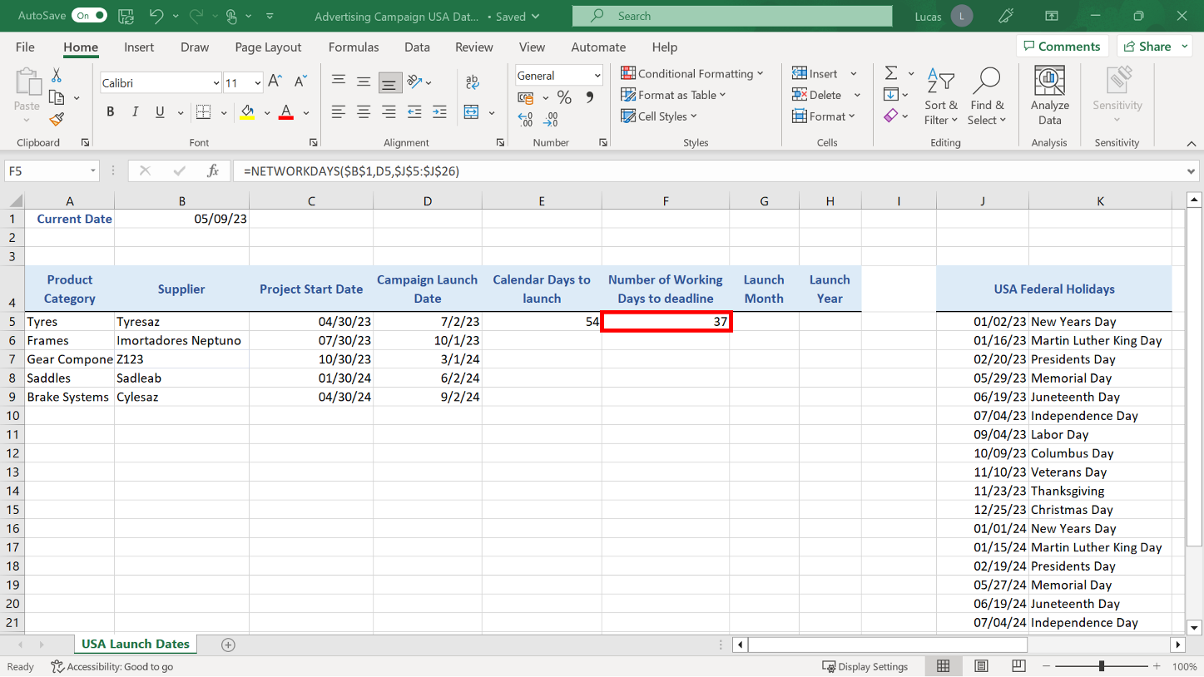

1. In cell **G5** you created a formula to extract the month component from the deadline date in **D5**. The **MONTH** function examines the complete date in **D5**. It identifies the month and displays that as a result.

The formula in **G5** should read:

**=MONTH(D5)**

The result is 7.

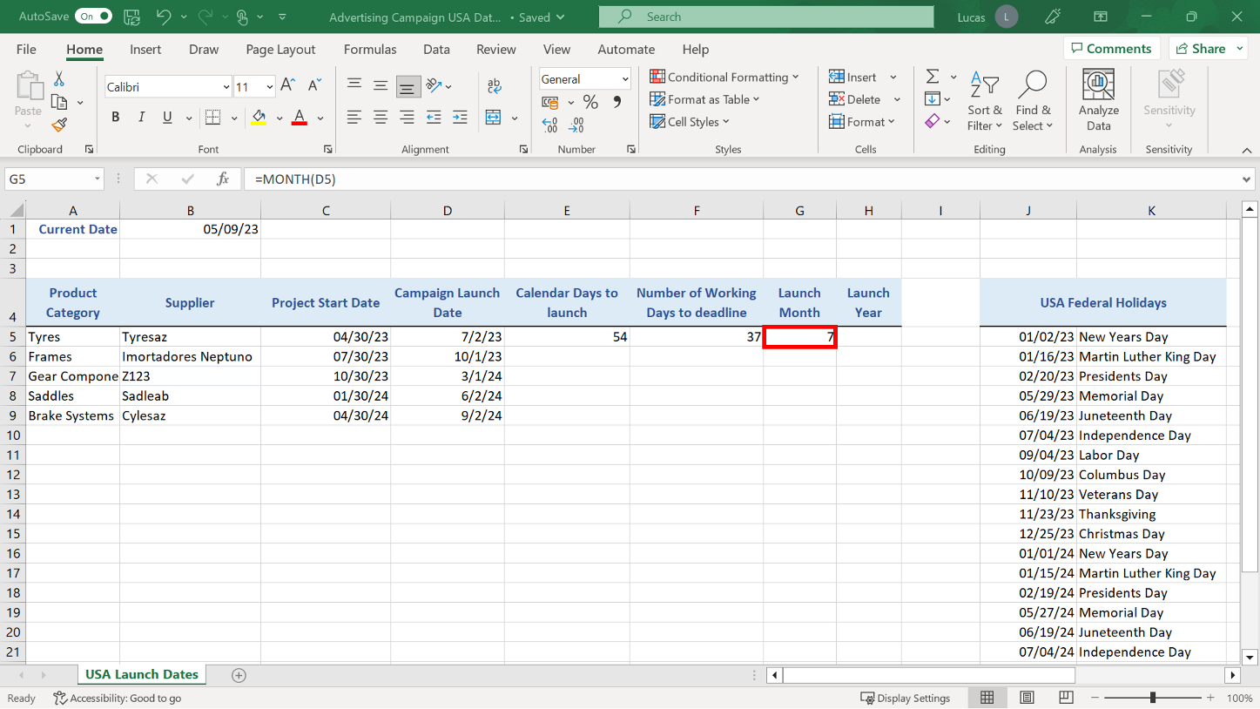

1. In cell **H5**, you created a formula using the **YEAR** function to extract the year from the deadline date in **D5**. The **YEAR** function examines the complete date in **D5,** identifies the year, and displays that as a result.

The formula in **H5** should read:

**=YEAR(D5)**

The result should be 2023.

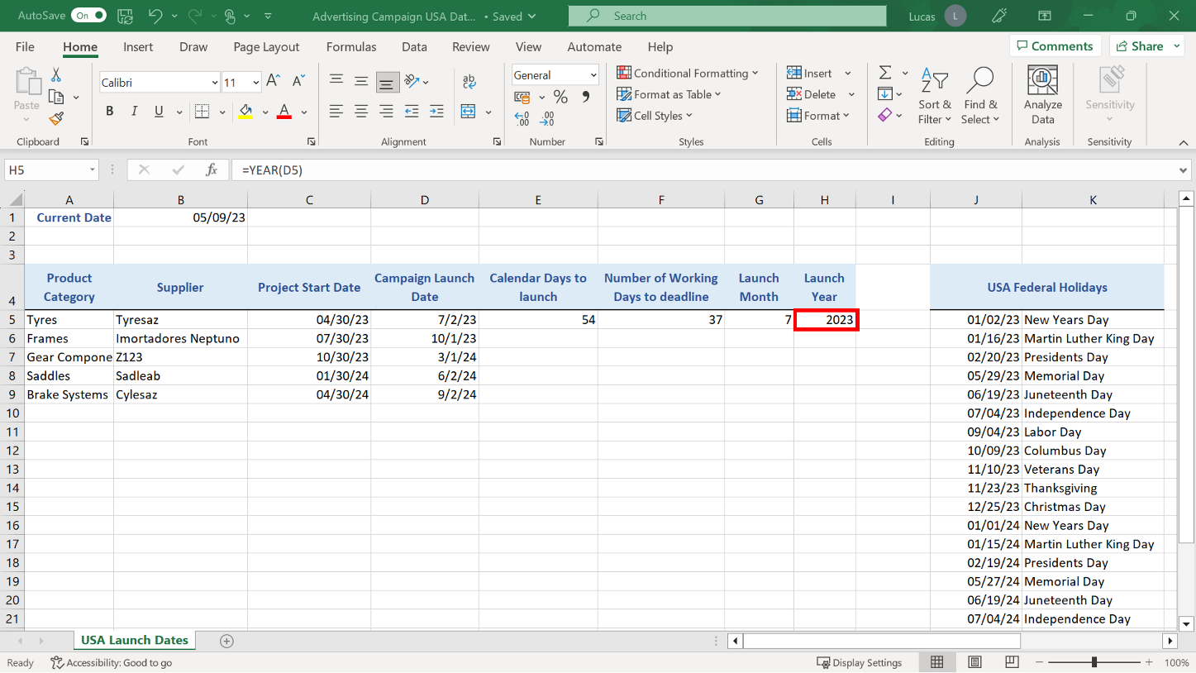

1. The final task you completed was to copy the formulas you had created in row **5**, down as far as row **9**. With the cursor on **E5**, then you could have used the double-click shortcut to copy the formula down as far as row **9**. Excel uses the block of dates in **D5** to **D9** as a reference for how far to copy the formula. If you highlight the four cells and then use the double-click shortcut on the **H5** entry, you can copy all four formulas down to row **9** at the same time.

Alternatively, you could have used the standard **Copy and paste** feature to copy the original formulas in row **5** and copy them into the empty cells underneath.

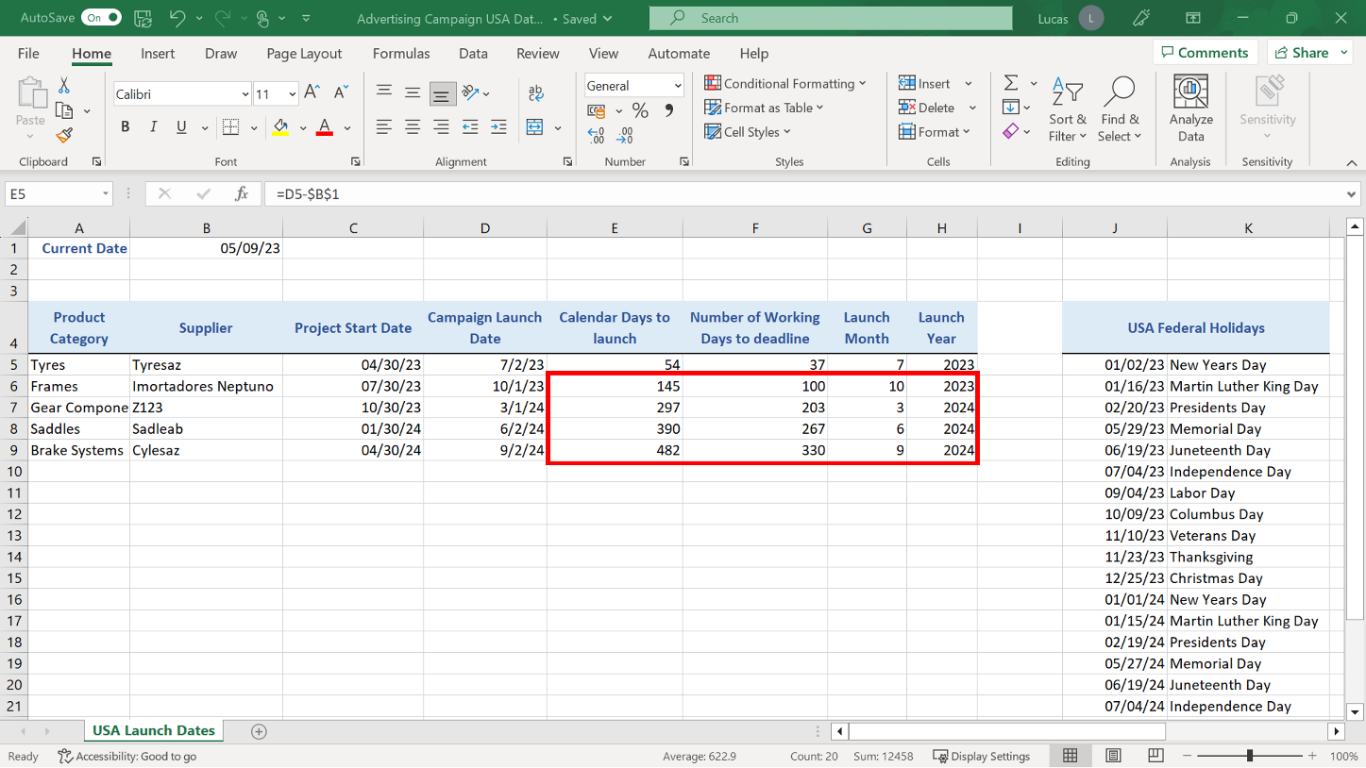

**Conclusion**

Congratulations! You have successfully finished this exercise, and you have used a range of date function formulas to add important milestone information. You can now notify Lucas that the spreadsheet is complete and can be used as a resource for the project plan.